Dispersed – Satellite (outdoor) settings

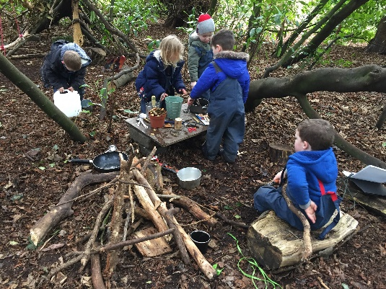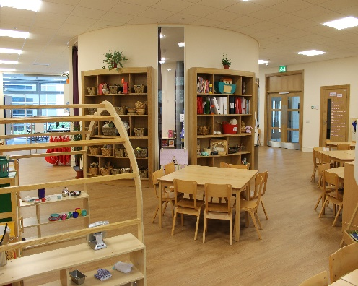

This model is where there is an outdoor satellite space not adjacent to the premises registered as part of the premises based setting. This might be a forest, park or other outdoor space and can be within walking distance of the building setting or further afield. The setting is run by a single provider, manager and one overall staff team. This model involves some children spending some of their time at the indoors setting and some at the outdoors setting ie. a split placement between indoors and outdoors. Parents must be aware that the agreement is to their child receiving their early learning and childcare in dual locations and their contract with the setting must reflect this. The dual location supports children to have indoor and outdoor experience. The outdoors elements of these settings will mirror the outdoor or forest kindergarten settings and the provider will need to have plans in place for shelter, toilets, hygiene, resources, and transport arrangements for children moving between the locations. Consideration needs to be given to contingency arrangements if on a rare occasion children cannot access the outdoor setting.

An additional condition is added to the registration to reflect the setting is provide over two different sites.

Settings

Beanstalk Family Nurture Centre
Craighead Country Nursery School
Duthie Park Outdoor Nursery
Hyde ‘n’ Seek Nursery
Hyde ‘n’ Seek On The Green
Jigsaw Nurseries
Kelvinside Academy Green Forest Nursery
Kirktonholme @ Coatbridge
Liberty Kids
MACS St Cadoc’s
Oakwell Children’s Nursery
St. Columba’s School
Sunflower Family Nurture Centre Lochgelly
The High School of Glasgow kindergarten
Treetop Family Nurture Centre

Useful guidance

Out to Play: https://hub.careinspectorate.com/media/1289/out-to-play-creating-outdoor-play-experiences-for-children-practical-guidance.pdf

My World Outdoors: https://hub.careinspectorate.com/media/1557/my-world-outdoors-sharing-good-practice-in-how-early-years-services-can.pdf

Early Learning and Childcare: Delivering High Quality Play and Learning Environments Outdoors – Practice Note
https://www.careinspectorate.com/images/ELC_practice_note.pdf

