Indoor/outdoor settings
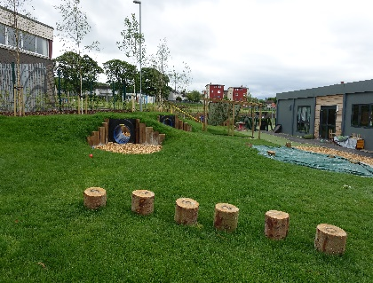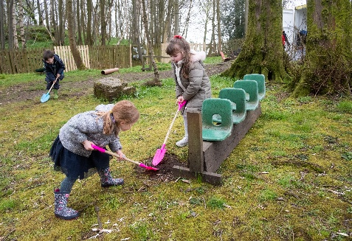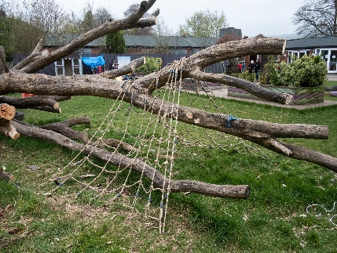
This model is as an indoor setting but where the scale and quality of the outdoor space is appropriate for enhancing the child’s quality of play and learning experiences and is suitable to register additional capacity and high quality natural outdoor spaces when combined with the indoor space. Both indoor and outdoor areas will be accessible to children 100% of the operational time.

An additional condition is added to the registration to reflect the setting is an indoor/outdoor setting.

Settings

Aboyne Primary School Nursery
Auchinairn Early Years Centre
Auchterhouse Nursery
Balmalloch Nursery
Cairellot Nursery Ltd
Castlegate Nursery & Out of School Club Limited
Castlemilk Day Nursery
Caz's Kiddies In The Country
Clentry Nursery School
Cornerstones Nursery
Darvel Early Childhood Centre
Devonview Family Learning Centre
Dreams DayCare Limited
Drumfork Nursery and Family Centre
Glenpark Children’s Centre
Gryffe Manor Nursery
Happy Days at Hardengreen
Houston Early Learning and Childcare Class
Hythehill Primary School Nursery
Holm Early Learning and Childcare Centre
Inverarity Pre School Class
Kidstore Childcare Ltd
Kilmaurs Early Childhood Centre
Kirklandneuk Early Learning and Childcare Centre
Kirktonholme @ Canniesburn
Kirktonholme @ Newton Mearns
KLAS Care
Lenzie Meadow Early Years
Little Hands Nursery Centre
Little Stars Alloa
Lochfield Early Learning and Childcare Centre
Murroes Pre School Class
Nether Robertland Early Childhood Centre
Netherthird Early Childhood Centre
Parkview Nursery
Rainbow Nursery – Paisley
Rocking Horse Nursery – Aberdeen
Rothes Primary School Nursery
Rowena Nursery School
Spateston Early Learning and Childcare Centre
St. Mirins Out of School Club
Sunflower Family Nurture Centre
South Lodge Primary School Nursery
The Glasgow Academy - Newlands Nursery
The Tower Nursery
Tip Toes Children’s Nursery

Useful guidance

Early Learning and Childcare: Delivering High Quality Play and Learning Environments Outdoors
https://hub.careinspectorate.com/media/1157/delivering-play-and-learning-environments-outdoors-practice-note.pdf

