Outdoor settings
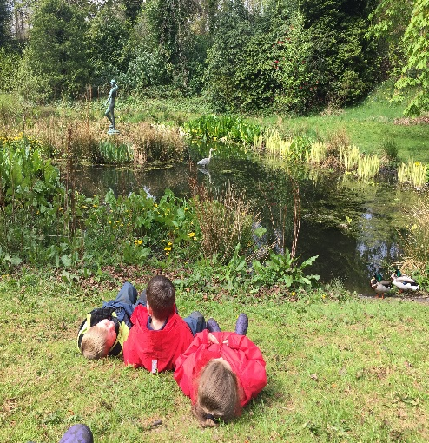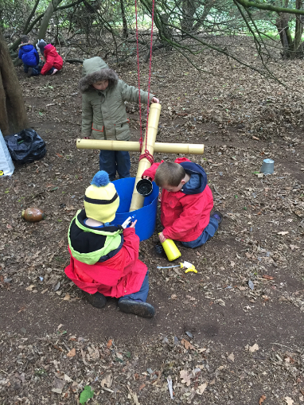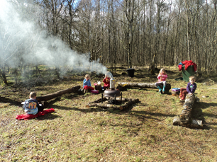
In these settings children are outdoors all of the time except in extreme weather conditions. Children and staff will have access to a sheltered area this could be a permanent or temporary structure. There may also be a meeting point, premises or a base camp used for the drop off and collection of children. These settings will have a comprehensive contingency plan which has been articulated and agreed with parents in the rare occasion where severe weather conditions prevent children from being outside.

Settings

Abriachan Forest School
Auchlone Nature Kindergarten
Bushcraft Bairns
Bonaly Forest Kindergarten
Cammo Forest Kindergarten
Corstorphine Hill Forest Kindergarten
Chapter One Childcare Dalkeith Treetops
Dalmahoy Woodland Family First Nurseries Limited
Drumfork Forest School and Out of School
Dunbar Private Nursery
Earthtime Elgin Forest School Nursery
Earthtime’s Forest School Nursery
Escape to the Story Outdoor Nursery
Evergreen Outdoor Nursery
FossoPLAY Outdoor Nursery
Forest Foxes Kindergarten
Greenhill Outdoor Nursery
Haddo Woodland Kindergarten
Hawkhill Forest Kindergarten
Hazelhead Park Outdoor Nursery
High Flyers @ The Woods
Kinder Croft CIC Outdoor Nursery
Lauriston Castle Forest Kindergarten
Little Bugs
Little Bugs Nursery
Little Bugs at Fordell Firs
Little Doe Daycare
MAKI Pups
Methilhill Nature Nursery
Mucky Boots
Newbattle Forest Kindergarten
Nurtured By Nature Kindergarten
Off Grid After School
Queensferry Forest Kindergarten
Riverside Cottage Nursery
Silver Birch Outdoor Nursery
Stramash Outdoor Nursery
Stramash Outdoor Nursery Tornagrain
Stramash Outdoor Nursery, Elgin
Stramash Outdoor Nursery, Fort William
Templars Park Outdoor Nursery Aberdeen
The Forest Nursery at Merchiston
The Nature Nursery Montessori Ltd
The Secret Garden Outdoor Nursery
Vogrie Outdoor Early Learning and Childcare
W.I.L.D. Forest School OSC
Wild Sparks
Wild Wellies Kindergarten Ltd
Willow Den at The Falkirk Wheel
Willow Den at Spartans
Woodland Play Ltd
Wonder Woods Woodland Nursery
Woodland Outdoor Kindergartens- Eastwood
Woodland Outdoor Kindergartens- West End

Useful guidance

Out to Play – Practical guidance for creating outdoor play experiences in early learning and childcare
https://hub.careinspectorate.com/media/1289/out-to-play-creating-outdoor-play-experiences-for-children-practical-guidance.pdf

My World Outdoors
https://hub.careinspectorate.com/how-we-support-improvement/care-inspectorate-programmes-and-publications/my-world-outdoors/

Early Learning and Childcare: Delivering High Quality Play and Learning Environments Outdoors
https://hub.careinspectorate.com/media/1157/delivering-play-and-learning-environments-outdoors-practice-note.pdf

