

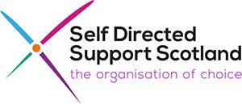

Self-directed Support Standard 13

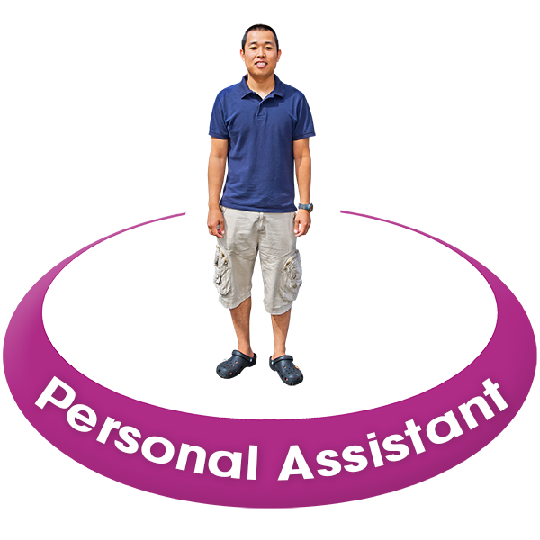
When direct payments are used to employ Personal Assistants (PAs)
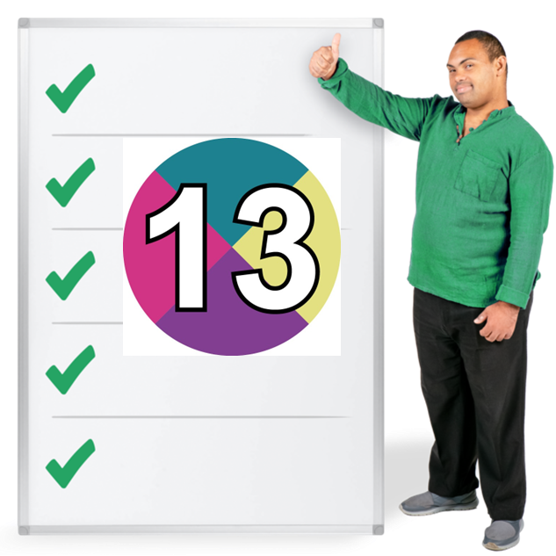



Easy Read



About this document
 | This is an Easy Read information document about new guidance called Self-directed Support Standard 13.
 | The information was written by Social Work Scotland with help from lots of people interested in Self-directed Support including people from the Personal Assistant Programme Board.
  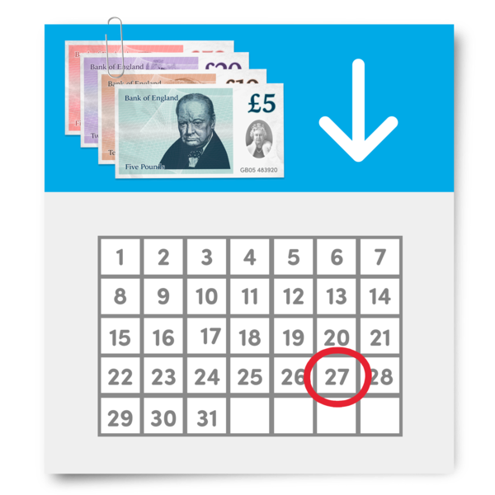  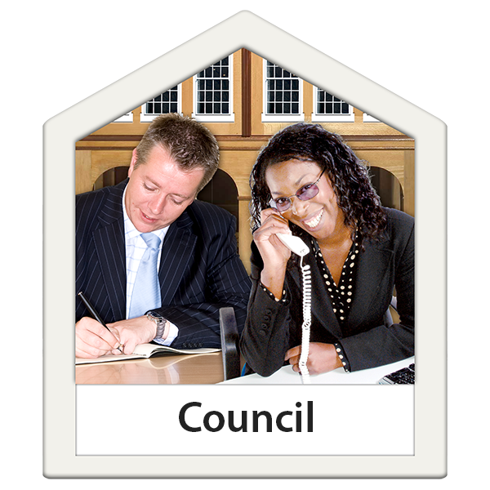 | Self-directed Support is when people choose how their support is organised.  There are 4 ways or ‘options’ to do this.  Direct payments are option 1 of Self-directed support.  In this document, direct payments mean money paid by a local council to a person.  The person can then pay for the support they want.
 | This includes employing Personal Assistants.  Employ means to choose someone to work for you and pay them a wage.  Personal Assistants are staff who are paid to help someone live independently and take part in community life.

About Standard 13
 | There are 12 Self-directed Support Standards.  These are 12 important things that local councils will work on to make all the options of Self-directed Support better.  You can read about the 12 Self-directed Support Standards in this Easy Read document.
 | Standard 13 has been added now.  Standard 13 is more guidance to help make option 1 better for when people employ Personal Assistants.
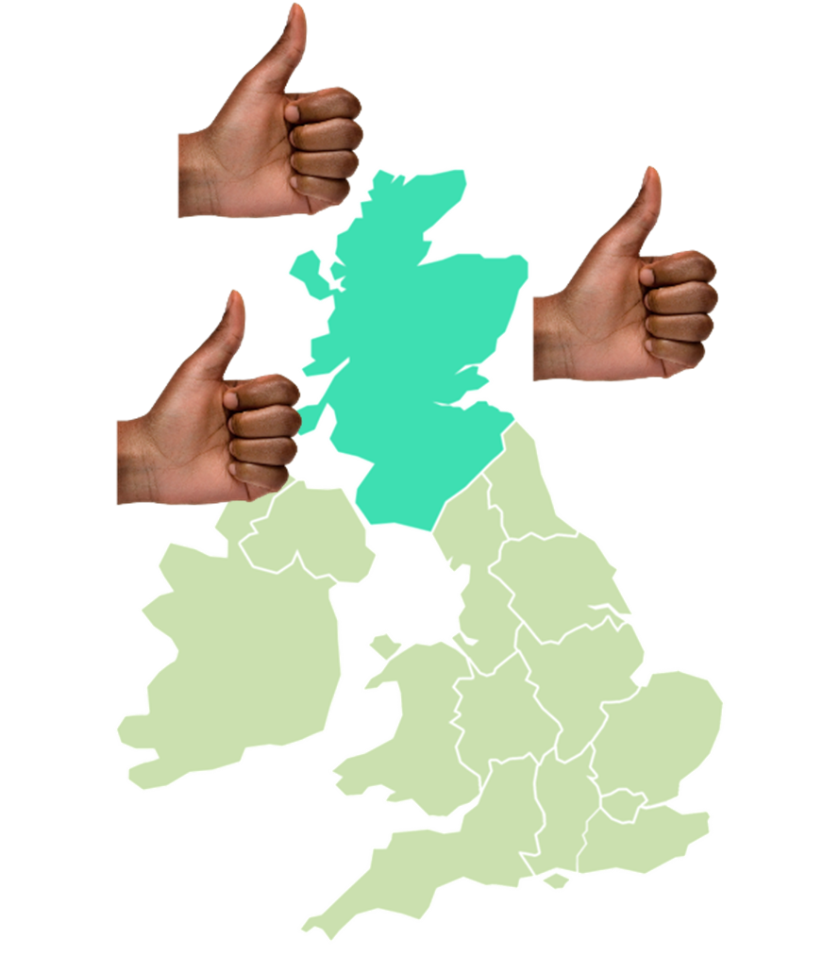 | The Standards mean that wherever in Scotland someone lives, you should be offered good support.
   | Standard 13 says:  - what people who employ Personal Assistants should get – this is called a Standard Descriptor  - what staff, systems and organisations will do – this is called a Practice Statement

Standard 13 – when direct payments are used to employ Personal Assistants
 | People who employ Personal Assistants should get from Standard 13:  - a payment of money from their local council called a direct payment
 | - the ability to use their direct payment to buy what helps to meet their outcomes – what they want to happen
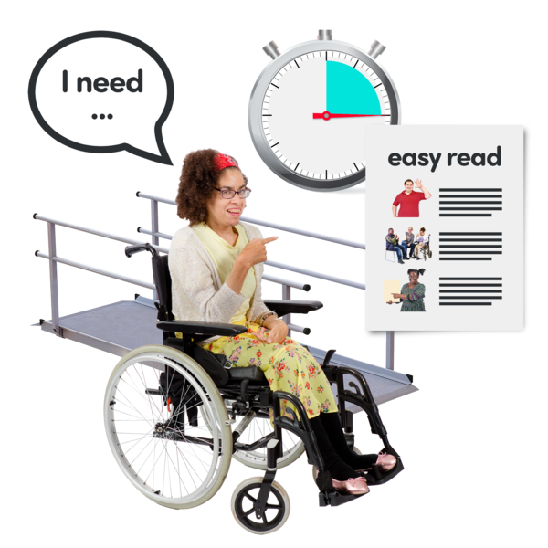 | - control over their support and independent living
Following Standard 13 means that the local council:

- gives you enough money to employ your own Personal Assistants
 | - supports you to be a good employer  - helps you to understand your responsibilities in being a good employer  - gives you helpful information about local people who can help you
   | Following Standard 13 means that independent support organisations:  - give you information about being an employer  - give you help to recruit Personal Assistants  - help you with your responsibilities in employing Personal Assistants
 | Becoming an employer means you have responsibilities – things you have to deal with.
   | In this document the responsibilities mean things like:  - finding people to be your Personal Assistant  - explaining what you want the Personal Assistant to do for you
 | - helping your Personal Assistant to get the training they need  - paying your Personal Assistant including holiday and sick pay
 | Direct payments can be offered to anyone who needs them, however small or big their support needs are.
 | Getting a direct payment means it is easier for a person to get their right to live as independently as possible.
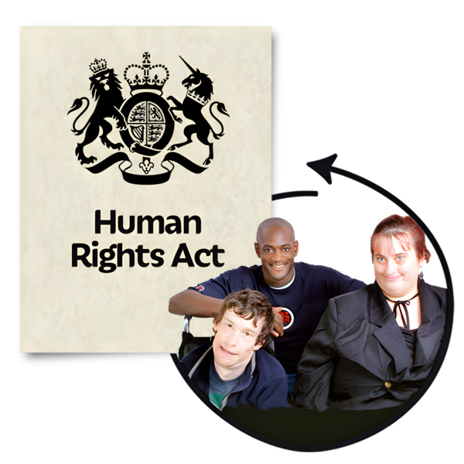     | The United Nations is an organisation that works with countries to keep peace and security across the world.  The right to live independently is in the United Nations Convention on the rights of people with disabilities.  A convention is an agreement that means countries will protect human rights in the same way for everyone.
 | Human rights are the basic rights and freedoms that belong to every person in the world.  They make sure we are treated fairly and with dignity.

More information
   | If you want to know more about Standard 13 you can email us at: sds.team@socialworkscotland.org  If you want to know more about being a Personal Assistant employer, look online at:  https://handbook.scot/the-pa-employer-handbook/  If you want to know more about independent support organisations, look online at: https://www.sdsscotland.org.uk/


